GitHub Repository Setup

1. 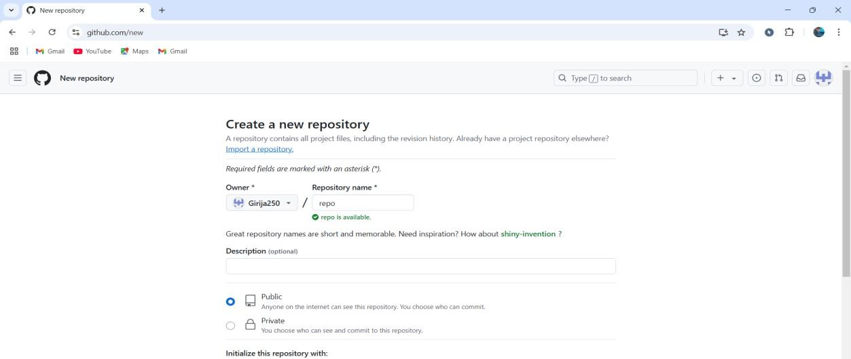Create a new repository in github.
2. Add a README file while creating a repository.

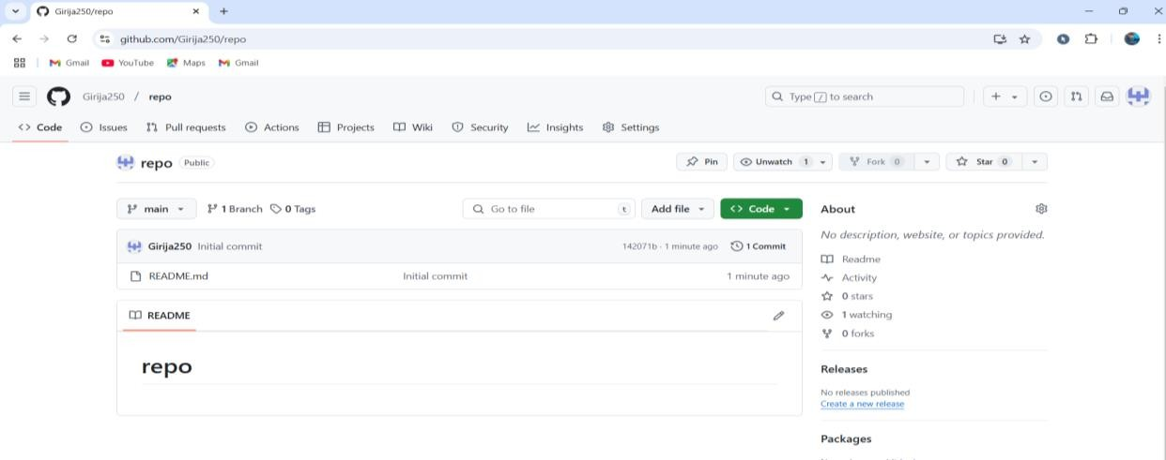

1. Copy the url of the new repository.

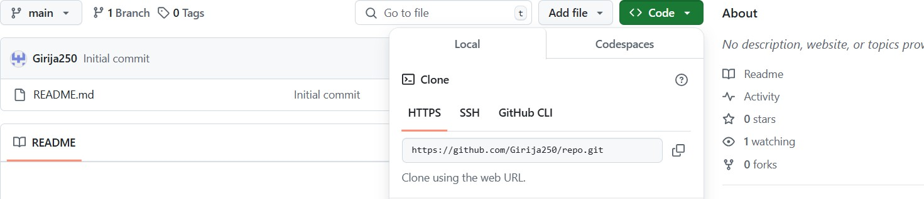

1. Open the git bash in folder and clone the new repository by using the url.

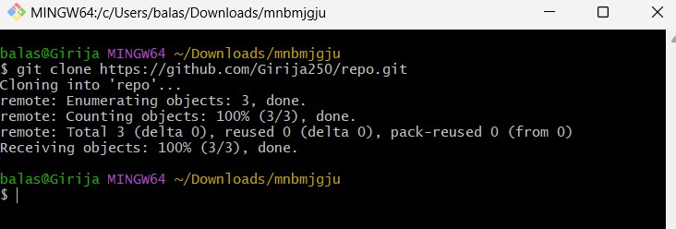

1. Verify the clone of github repository in folder.

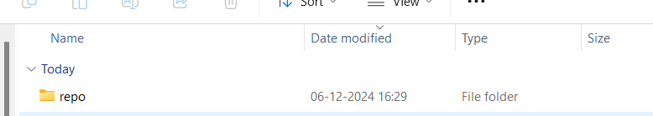

1. Now make the changes in the readme file and push it into github as follows.

